Instituto Politécnico Nacional

Escuela Superior de Cómputo

Evolutionary Computing

5 Introduction to Swarm Intelligence

Martínez Coronel Brayan Yosafat

Rosas Trigueros Jorge Luis

8/10/2021

15/10/2021

## Theorical framework

The word "fractal" often has different connotations for the lay public as opposed to mathematicians, where the public is more likely to be familiar with fractal art than the mathematical concept. The mathematical concept is difficult to define formally, even for mathematicians, but key features can be understood with a little mathematical background [1].

The feature of "self-similarity", for instance, is easily understood by analogy to zooming in with a lens or other device that zooms in on digital images to uncover finer, previously invisible, new structure. If this is done on fractals, however, no new detail appears; nothing changes and the same pattern repeats over and over, or for some fractals, nearly the same pattern reappears over and over [1].

So, in a few words, it scales at a strange rate and looks repeated.

## Material and equipment

In this practice, Google Colaboratoy with Jupiter Notebooks, Conda and Python were used for development.

## Practice development

The code used for this is based on a function given by the instructor. We just use the form number five from the original function. Something about that last spiral captives me, and trying to remember what is it I remember Van Gogh, a tragic story about love, depression a lots of… sunflowers.

Import cv2

import numpy as np

from google.colab.patches import cv2_imshow

import math

def ec(img, x, y, size, angle, delta_size, delta_angle, n, color=(22, 53, 64), type=’flor’):

    if n==0:

        return

    x2=x+size

    y2=y

    ar=math.radians(angle)

    coseno=math.cos(ar)

    seno=math.sin(ar)

    xrot= (x2-x)*seno + (y2-y)*coseno

    yrot= (x2-x)*coseno – (y2-y)*seno

    x2=xrot + x

    y2=yrot + y

    cv2.line(img, (int(x),int(y)), (int(x2),int(y2)), color, (1))

    if type == ‘flor’:

        color = (3, 186, 252) if n < 120 else (22, 53, 64)

        ec(img, x2, y2, size+delta_size, angle+delta_angle, delta_size, delta_angle, n-1, color=color, type=type)

    elif type == ‘sol’:

        ec(img, x2, y2, size+delta_size, angle+delta_angle, delta_size, delta_angle, n-1, color=color, type=type)

    else:

        cv2.circle(img, (int(x), int(y)), int(size), (255,255,255), -1)

        cv2.circle(img, (int(x), int(y)), int(size), (0,0,0), 1)

        ec(img, x2, y2, size*delta_size, angle-delta_angle, delta_size, delta_angle, n-1, type=type)

        ec(img, x2, y2, size*delta_size, angle-2*delta_angle, delta_size, delta_angle, n-1, type=type)

        ec(img, x2, y2, size*delta_size, angle-3*delta_angle, delta_size, delta_angle, n-1, type=type)

img = np.zeros((500, 500, 3), dtype=”uint8”)

img[:][:200] = [222, 170, 58]

img[:][200:] = [54, 122, 33]

img[0:50][250-20:250+20] = [36, 255, 240]

ec(img, x=250, y=0, size=50, angle=30, delta_size=0.3, delta_angle=100, n=400, color=(36, 255, 240), type=’sol’)

for y in range(200, 500, 20):

    for _ in range(5):

        x = np.random.randint(0, 500)

        ec(img, x=x, y=y, size=10, angle=30, delta_size=0.2, delta_angle=50, n=250)

cv2_imshow(img)

Code 1 and 2. Imports and code for the landscape

So, I wanted to make something just as a landscape of sunflowers, colorful and just looking at the original spiral gives me the vibes of a flower, but I needed to adjust the color. I added some randomness just for fun, I change the background color, so it looks more realistic, this was the first attempt of making a landscape:

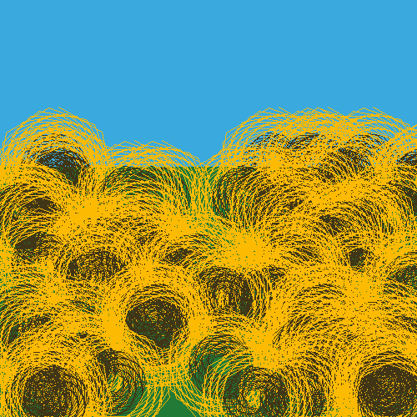

Fig. 1. Landscape of sunflowers

And I love, but, that sky, it just looked so simply, there was something I forget, I really liked those sunflowers, it looks like threads, and imaging something made of threads made think about real art with just threads like the rainbow. With this, I remember the sky, the sun was the next thing I wanted to add.

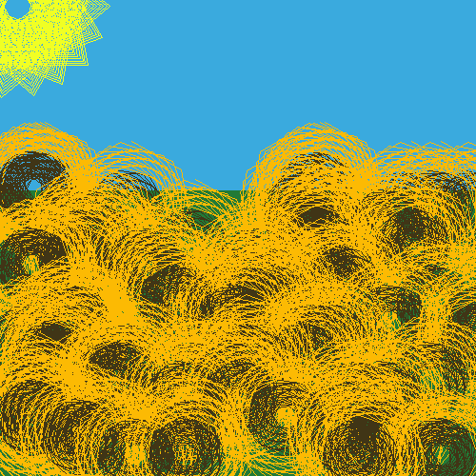

Fig. 2 Sun greets the sunflowers

The sun was like a sunflower, but, the angle, color and length were different, I liked but, that sky, it just feels void, so I decided to change the position of the sun and making it a little bit bigger.

Fig. 3 Threads of sun

## Conclusions and recommendations

When I felt good about the sensation of the landscape, I closed my eyes, and feel like it was thread just from the sun itself, it felt like a travel from the lands of something golden, like wheat from the little prince book. I have read some articles about technology in art, but I never tough about making something like that. I know it is simple, but recreating something played many years before, or creating a new painting based on Rembrandt, it is just amazing.

## References

[1] Wikipedia. Fractal. Oct. 11, 2021. Wikipedia. Accessed on: Oct. 11, 2021. [Online] Available: https://en.wikipedia.org/wiki/Fractal